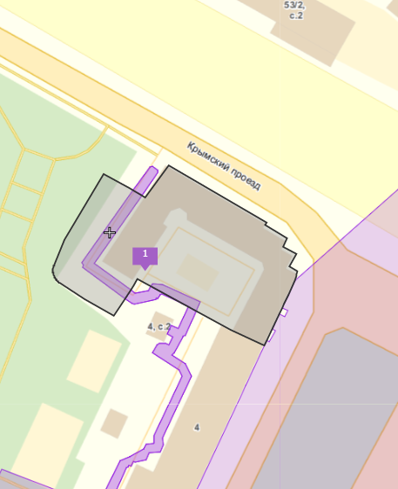

**01/01/19502**

**01/01/19503**

77:01:0005016:3966

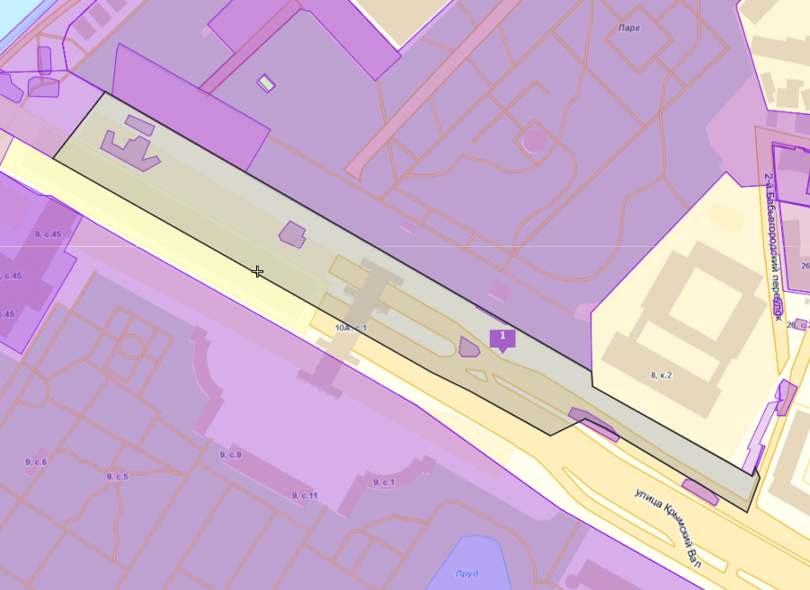77:01:0002001:30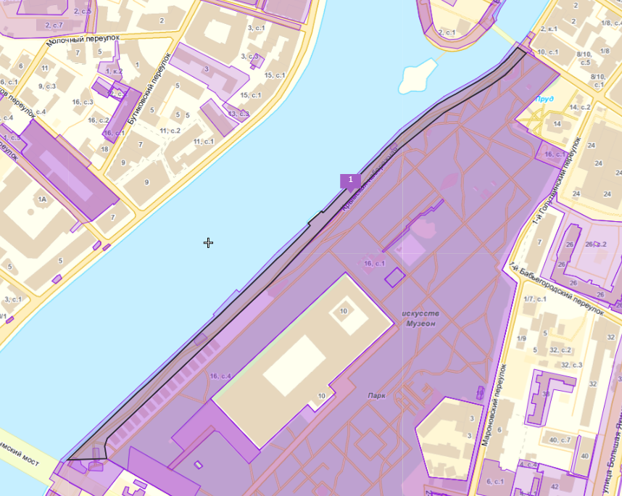

**01/01/19485**

**01/01/19484**

**01/01/19483**

**01/01/19482**

**01/01/19481**

**01/01/19480**

**01/01/19496**

**01/01/19495**

**01/01/19494**

**01/01/19493**

77:01:0002001:1197

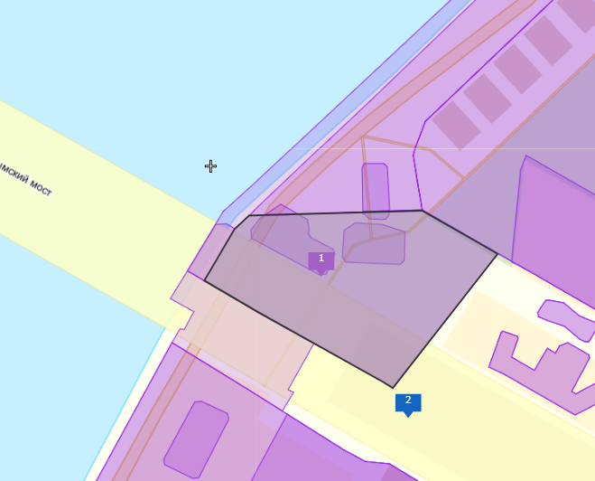77:01:0002001:1196

**01/01/1950101/01/19500**

**01/01/1950001/01/19500**

**01/01/1949901/01/19500**

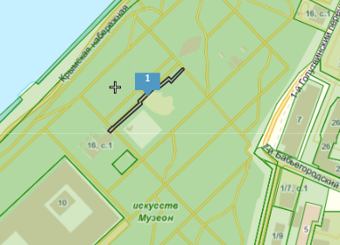

**01/01/1950401/01/19500**

77:01:0002001:1

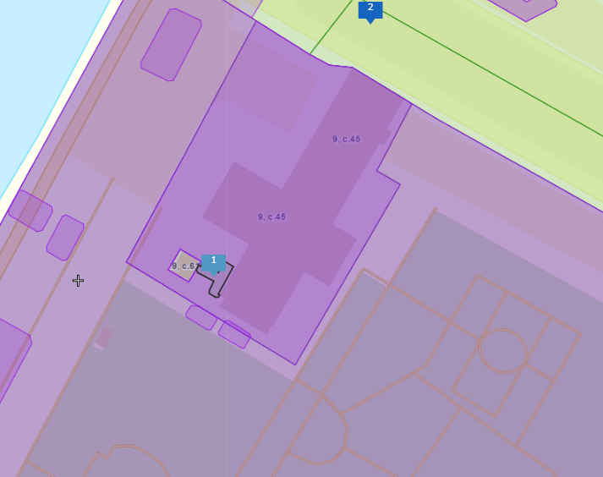77:01:0006001:1838

**01/01/1947901/01/19500**

**01/01/1947801/01/19500**

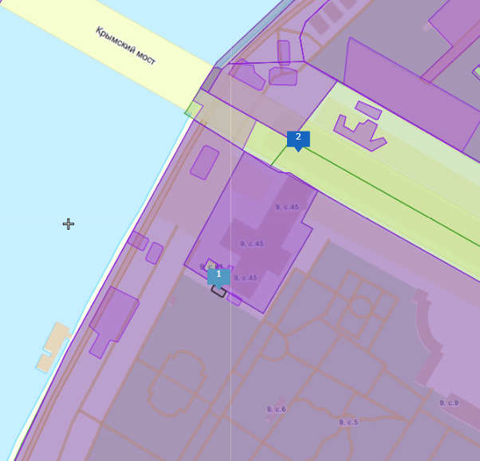

**01/01/1949201/01/19500**

**01/01/194911/01/19500**

**01/01/194901/01/19500**

**01/01/1948901/01/19500**

**01/01/1948801/01/19500**

**01/01/1948601/01/19500**

77:01:0006002:4

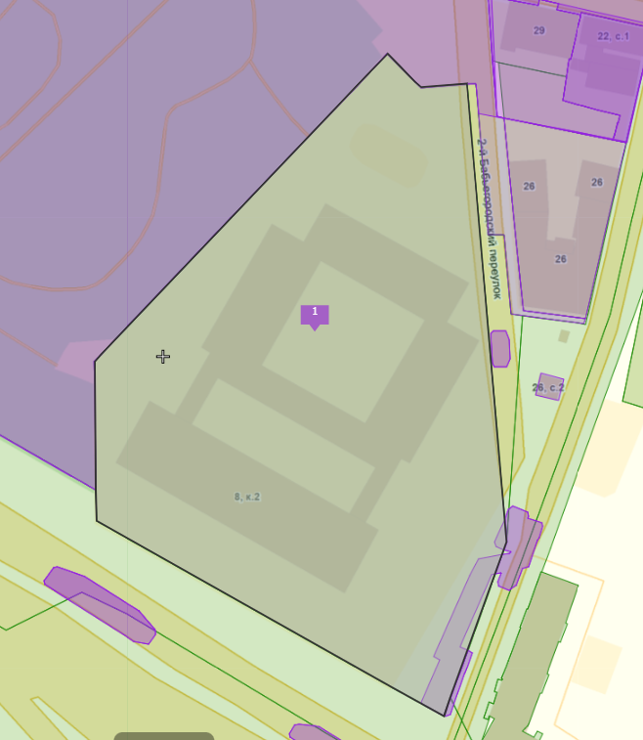77:01:0002001:4

**01/01/194971/01/19500**

**01/01/194971/01/19500**